

RI District 3310

END POLIO Trans-Sabah Walk and Climb
Sandakan – Mount Kinabalu – Kota Kinabalu
7th – 18th November 2011

- The Walk from Sandakan to Kota Kinabalu is a distance of 326km.
- The Climb up and down Mount Kinabalu is another 2 days.
- The Finish is at the District Conference in Kota Kinabalu on 18th November 2011.

Participants will be a team of 10 to 15 Rotarians from various parts of District 3310.

It is a challenging course. We will be crossing the scenic Crocker Range which separates the east coast and west coast of Sabah. At an average height of 1800m, it is the highest mountain range in Sabah. Mount Kinabalu at 4095m, one of the highest mountains in South-east Asia is part of this range.

We will plant Rotary’s ‘END POLIO NOW’ flag at the peak of Mount Kinabalu – a valuable piece of PR.

Many, many other Rotarians, families and friends, especially those attending the District Conference, are expected to participate by walking the last leg on the last day, all donning ‘END POLIO NOW’ t-shirts.

Purposes

- To support Rotary’s ‘END POLIO NOW’ campaign, its quest to rid polio from the face of the Earth;
- To inspire, to motivate Rotarians and the public to donate to The Rotary Foundation’s US$200 Million Challenge;
- To enhance Rotary’s internal image among Rotarians; and
- To enhance Rotary’s external, public image

Target

To raise at least US$100,000 for TRF’s US$200 Million Challenge. All clubs in the district are encouraged to participate with Rotarian and public donations.

Funding

This is a district-sponsored project. Participants are expected to fund much of the project themselves, with some district support.

COMMITTEE

Advisor
DG Hj Zainie Abdul Aucasa

Co-Organising Chairs
PP Tay Wei Lien, RC Singapore West wltayqs@gmail.com
PP Leong Chee Woh, RC Johor Bahru cheewohrotary@gmail.com

Chair, Logistics & Support (Sabah)
PP Wong Chu Lai, RC Likas Bay

Technical Advisor
PP Robin Tay, RC Pudu (D3300)


Promotion print

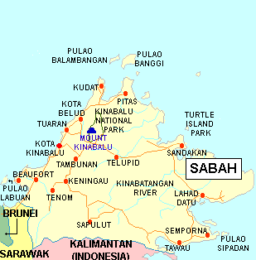
Map of Sabah, part of the island of Borneo.

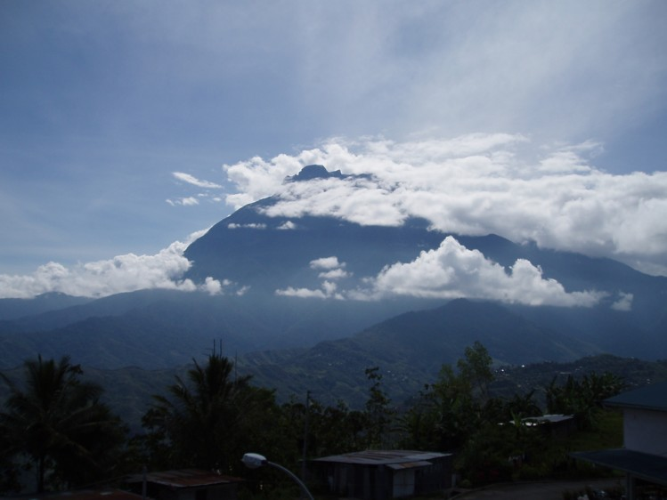
Mount Kinabalu (4095m).

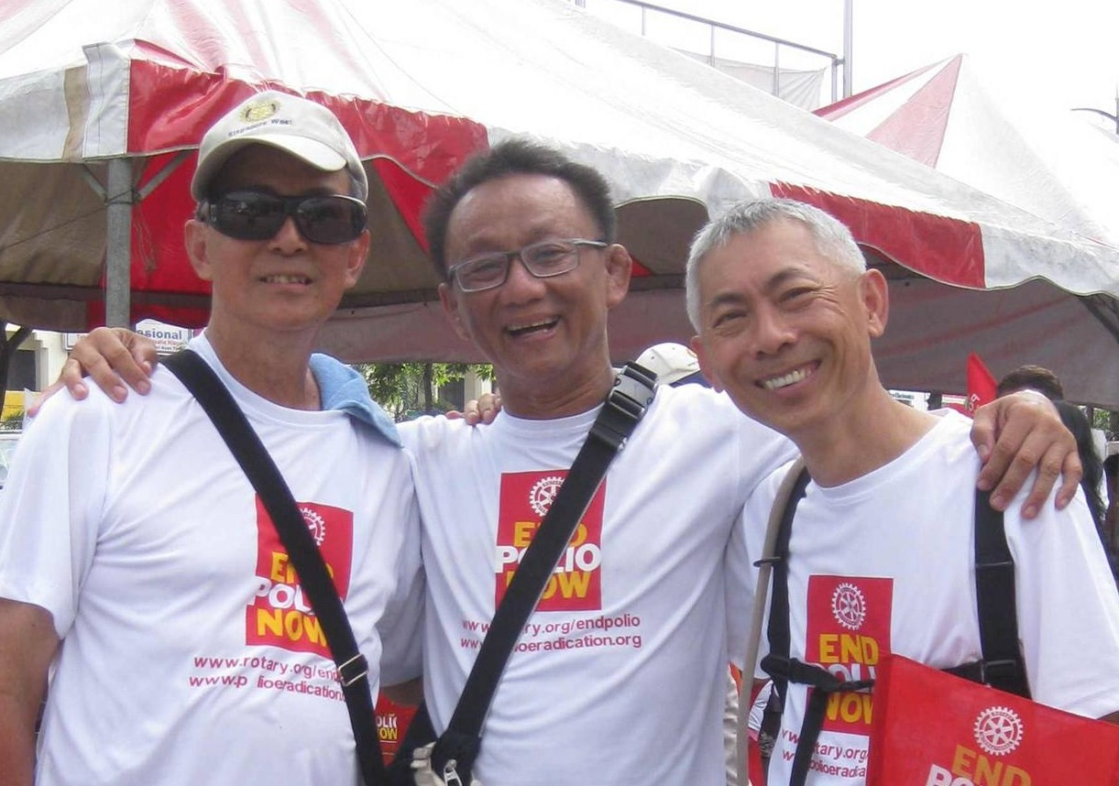

L-R: Wei Lien, Chee Woh & Robin in the Walk To End Polio – KL to Singapore, 20-30 Dec 2010.

