**Interact Club of ITE College East**

**Installation “in-the-Dark” Ceremony**

**16 July 2010**

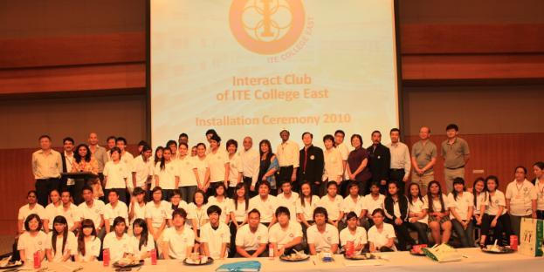

The Interact Club of ITE College East held its Installation Ceremony on Friday 16 July 2010. But the format for this year’s installation was different. Since the Club’s emphasis for 2010 is Avoidable Blindness, the Club organized, in conjunction with the Singapore Association of the Visually Handicapped (SAVH), a Dining-in-the-Dark experience for its 180 guests. SAVH confirms that this is the largest single dining-in-the-dark event ever organized in Singapore where all participants are seated together in one room.

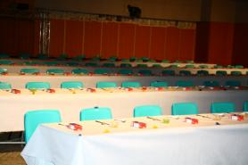

As you can see, ITE’s Function Hall was converted into a dining room and configured like a conference with 10 rows of tables with 20 seats on each row.

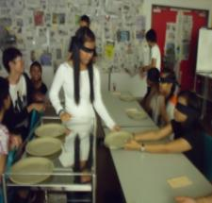

Due to the size of the event, preparations started several months before the event. For example, during the school vacation a group of 20

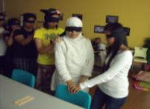

members practiced for 2 weeks for their role as blind guides/servers in a mock-up room where all windows were covered with newspapers. SAVH provided trainers to help guided students and gave pointers on how to improve the arrangement of the room.

The members also built a tent and used black rubbish bags for curtains. The tent was positioned at front of the function hall door and acted as an “eye acclimatization” area before guests are led into pitch dark the dining hall.

Prior to the dinner, a Carnival of the Senses was held with the aim of reinforcing the message that our eyes are important and for guests to explore the sensitivity of their other senses. One game required blindfolded guests to locate safety pins that we hidden in a bowl of rice. (this game was borrowed from Dailogue-in-the-Dark.) Other games involved the sense of smell, taste and hearing.

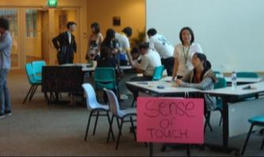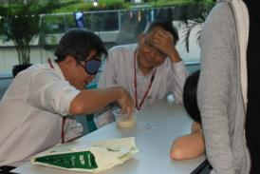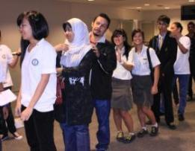

At 7pm, guests were called to form lines of 6 persons per line. Explanations were given as to what to expect inside the function hall, how to locate their cutlery on the table and how to receive their food from the servers. Initially, it was chaotic, but after a while the lines of 6 persons, with hands on shoulders, marched in unison into the acclimatization tent and then into the darkened Function Hall.

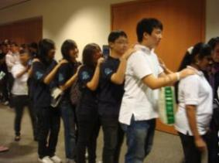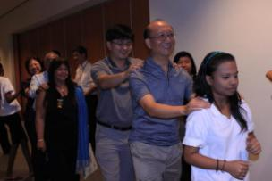

Whilst all of this was going on, the serving crew was preparing the food and placing the plates onto the trolleys. It was like a beehive that was buzzing with activity. The menu for the evening was a simple one and included Fish & Chips and a homemade Jelly desert.

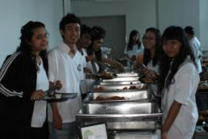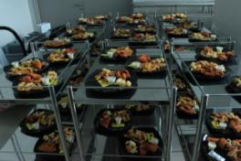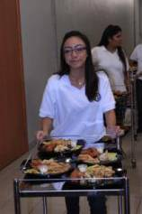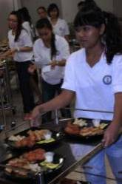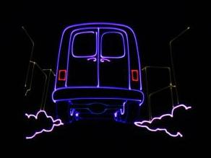

After dinner, the guests were treated to 10 minutes of entertainment in the dark created by the students of ITE. The first skit was a tour of the Singapore Aerospace Show, where guests heard a reenactment of a “dog fight” with single engine fighter aircraft from World War II. The second skit, called the Heartbeat, was the bus journey back to ITE from the Singapore Aerospace show. It was an exciting journey for our partially blind guests because the skit included snippets of events that could potentially happen on such a journey. These included being chatted-up by a girl or nearly being knocked down by a car which can cause an accelerated heartbeat. The skit also included a laser show depicting the various events that happened during the journey.

The theme for the evening was “I make the difference – the next step”. The first step would be to understand and empathize with the position of a visually impaired person. The Carnival of the Senses, Dining-in-the-Dark, the visit to the Singapore Aerospace Show and the Heartbeat skit helped lay the foundation of empathy. However, what would the next step be?

SAVH provided this vision through our keynote speaker, Mr Ben Wong. Mr Wong lost his sight during adulthood due to retinitis pigmentosa (a type of retinal dystrophy that causes the progressive degeneration of the retina) and has been a client of SAVH since 1979. He spoke about acceptance and change. He said “The best life doesn’t come by chance. The best life comes by change.” Change, as in the way society (and us individually) views the visually impaired and by the way the visually impaired viewed themselves. He implied that the best “next step” would be a small one – to have more sighted people mix with and befriend the visually impaired so that mutual understanding and trust can be developed.

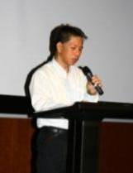

The evening was completed by speeches and the presentation of awards, the formal installation of all new members and the recital of the Pledge. Dr Abraham, DG of Rotary Singapore, presented Rotary’s Certificate of Commendation for the Best Interact Club Project to our President, Miss Rafidah Mhd Nor. In addition, certificates of appreciation were presented to Mrs Devaki Suppramaniam and Miss Elaine Tan (both Teacher Advisors to the Interact Club) for their

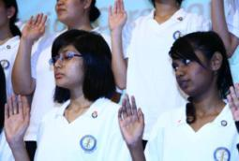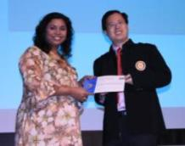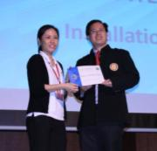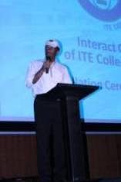

contribution and arrangement of the Advanced RYLA camp. Finally, the evening was rounded-off with our Family Dance. Everyone got up and had a whale of a time.

We would like to take this opportunity to thank a number of people and organizations – SAVH for the partnership and help in organizing this evening, Rotary eClub for their help and support, Cocoa Trees for their financial support,

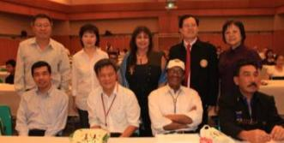

Maurice Tan & Ang Huan Ler as the main student organisers, our student guides & servers, our students who created the multimedia presentation and all our student volunteers and Teacher Advisors who made the evening such a success.

We only apologise that there are no pictures of the dinner because “it was in the dark!”

*Written By : William Chong, Teacher Advisor, Interact Club of ITE College East*