International Joint Community Project - Rural Lawas Medical Mission covering Long Tanid, Long Semadoh & Pa' Adang (Penan Settlement) on 02nd till 05th October 2009… by PP Ron Tan
On behalf of the Organizing Chairlady IPP Jenny Liew of the Rotary Club of Miri, the International Joint Community Project - Rural Lawas Medical Mission covering Long Tanid, Long Semadoh & Pa' Adang (Penan Settlement) on 02nd till 05th October 2009 has been a success and gruelling mission. It involved many hours of travelling in 4-wheeldrive vehicles thru "harsh, punishing roads" and about 2 hours of walking crossing rivers and jungle terrain to reach the Penan Settlement (Pa' Adang).

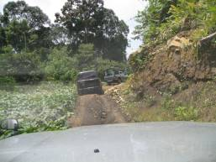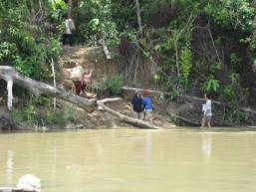

Our gratitude and appreciation goes to the management of Samling Sdn Bhd that provided experienced drivers and the 4WD vehicles to take us thru the gruelling roads and jungle terrain, without them, the success of the mission could have been jeopardised.
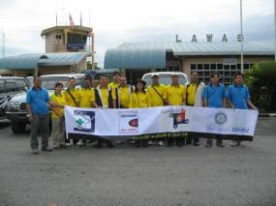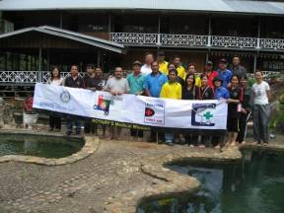

The Project was the "brainchild' of Rotary Club of Miri, jointly organized with rotary clubs of Belait, Bandar Seri Begawan & Medical Team of Miri/ Lawas. A similar project was carried-out last year 2008 covering only Long Tanid and Long Semadoh. This year, the project included the Penan Settlement (Pa' Adang) to provide medical examination the Penans. Long Tanid and Long Semadoh are populated by the Lun Bawang ethnic group. The team comprising 4 rotarians from the Rotary Club of Miri, 1 rotarian from the Rotary Club of Belait, 1 rotaractor from the Rotaract Club of Curtin, 5 doctors from the Miri Hospital, and 14 staff from the Lawas Hospital.
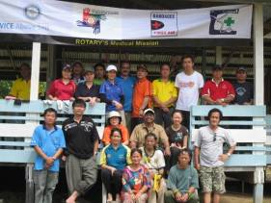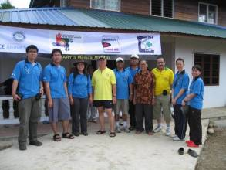
The Mission of the Project was to provide medical screening (blood pressure monitoring. heart-rate, gynecological consultation, cancer-screening for women, immunisation, deworming and eye screening) to the people living in Long Tanid, Long Semadoh and Penan Settlement (Pa' Adang). Eye glasses were also provided to all those with poor vision. About 200 adults and 200 children were examined in all 3 areas. Toys and snacks were also distributed to the children in these 3 areas. 40 schoolbags were given to the school-children at the Penan Settlement. A colouring competition was also organized for the 110 children of Long Semadoh with prizes awarded to the winners.
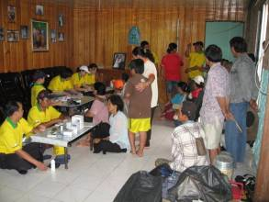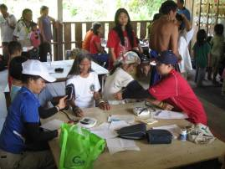
Some photos are attached for your viewing. A report is currently being prepared and shall be sent to the District Editorial Team for publishing in the DG Newsletter in due time.
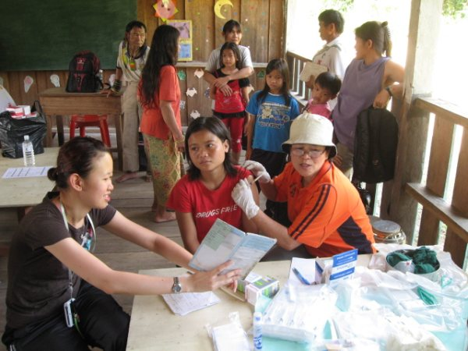
Vaccination-Pa Adang
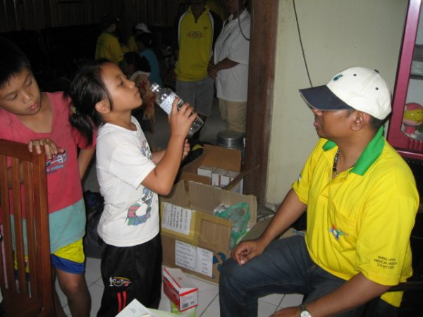
Deworming-Long Tanid
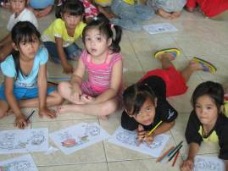
Colouring Competition-Long Semadoh

